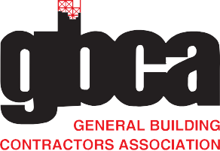
GENERAL BUILDING CONTRACTORS ASSOCIATION
36 South 18th Street Philadelphia, PA 19103

O 215.568.7015
F 215.568.3115

gbca.com

Dear Colleague,

Thank you for being a valued member of our team and an integral part of Philadelphia’s construction community. We value your professional commitment to be the best and want to remind you that our company is a member of the General Building Contractors Association (GBCA). While working for us, you can take advantage of GBCA’s member benefits, including some great educational opportunities:

- Tuition Reimbursement for construction-related college and university courses (for contractor members)
- Online, self-paced, on-demand construction classes
- Safety Training – in-person and online
- And more (visit gbca.com to learn more)!

GBCA is looking to expand their online course offerings, and wants your feedback:

What types of courses would you be interested in taking?

Send feedback to Angela Hendrix, Director of Training & Workforce Development, at ahendrix@gbca.com. Those who send feedback by January 5, 2021 will be entered to win an Amazon gift card.

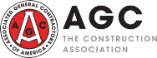
GBCA theGBCA @gbca theGBCA

