

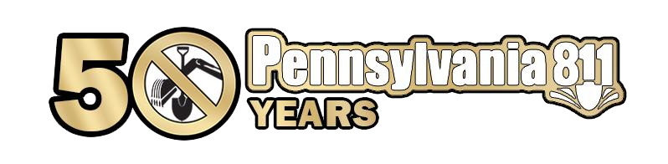

Register Today

**www.pa1call.org/SafetyDay**



Tuesday, May 17 at the Allentown Fairgrounds, Allentown

Thursday, May 19 at Drexelbrook Conference Center, Drexel Hill

Tuesday, June 7 at Monroeville Conference Center, Pittsburgh

Thursday, June 16 at the York Expo Center, York

Thursday, August 11 at Mohegan Sun Pocono, Wilkes Barre

Tuesday, September 20 at Bayfront Convention Center, Erie

Thursday, September 22 at Blair Convention Center, Altoona

**Keynote Speaker:** Monica Rakoczy, EnterTRAINING Solutions

*Delivering important safety messages in a fun, engaging manner*

*that leads to lasting impressions.*

**Tournament:** Global Locate Masters

**Training Track:** From Conception to Construction learn how to use

Coordinate PA to work efficiently through the One Call Process

**Guest speakers** covering subject matters on Principles on Paving, Underground Utility Locating, Subsurface Utility Engineering,

Bridge and Culvert Inspections

**Quick Learns** on Planning and Documenting your Worksite, Renotify and Update Tickets, Preconstruction Meetings, Online Ticket Management, KARL Response Codes



**Pennsylvania One Call: The Keystone of Damage Prevention www.paonecall.org**



**REGISTRATION FORM**

**STEP 1:** SELECT A METHOD TO REGISTER

ONLINE: [www.pa1call.org/SafetyDay](http://www.pa1call.org/SafetyDay) EMAIL: [registration@pa1call.org](mailto:registration@pa1call.org)

**STEP 2:** PREREGISTER FOR THE CONFERENCE WITH YOUR BASIC INFORMATION

Full Name: _____________________________________________________________________

Company Name: _____________________________________________________________________

Address: _____________________________________________________________________

City, State, Zip: _____________________________________________________________________

Telephone No.: (_____) _____________________ Email Address: __________________________

Attending lunch: ⬜ YES ⬜ No

DEP Client ID #: _____________________________________________________________________

Pennsylvania 811 and the Department of Environmental Protection Agency have partnered to offer a unique opportunity to all licensed water and wastewater operators. Water and Wastewater operators may earn up to two (2) DEP credits if you preregister, provide your active DEP CLIENT ID NUMBER and your FULL NAME as listed on your wallet card. You have two opportunities to give Pennsylvania 811 your basic information—1) on this registration form, or 2) when you check-in at the event. Pennsylvania 811 *will not* accept your basic information after the conference.

**STEP 3:** SELECT THE CONFERENCE YOU WILL ATTEND

⬜ Allentown ⬜ Drexel Hill ⬜ Pittsburgh ⬜ York ⬜ Wilkes Barre ⬜ Erie ⬜ Altoona

**STEP 4:** ONLINE INFORMATION at [www.pa1call.org/SafetyDay](http://www.pa1call.org/SafetyDay)

🗸Register additional registrants

🗸 Download the conference planner and session descriptions

🗸Watch the orientation video to plan your day

🗸Save the exhibitor list and venue layout

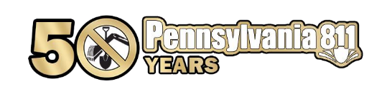 🗸Get directions to the conference venue

**Pennsylvania One Call: The Keystone of Damage Prevention www.paonecall.org**